WORKSHEET 1: Introduction to micro:bit

What is micro:bit?

The **micro:bit** is a tiny programmable computer. It has 5 x 5 LEDs and two programmable buttons with many other features such as an accelerometer, a compass and Bluetooth connectivity.

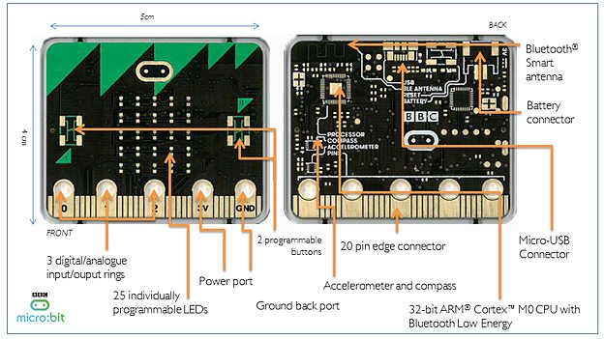

Using a web browser such as Google Chrome, the programming environment can be accessed with the URL, ***makecode.microbit.org***.

The block-based programming environment looks like the image shown below.

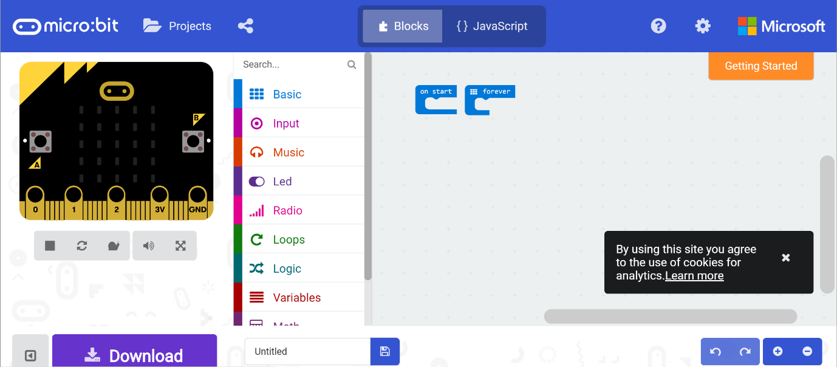

Programming area

Block code menu

Emulator: View outcome of the code

**ACTIVITY 1**

Program an LED animation using the ***show leds*** and the ***forever*** blocks which can be found in ***Basic*** menu.

1. Click on the ***Basic*** menu and drag ***show leds*** to the programming area.
2. Select the LEDs as shown by clicking on the light blue rectangles (5 x 5).

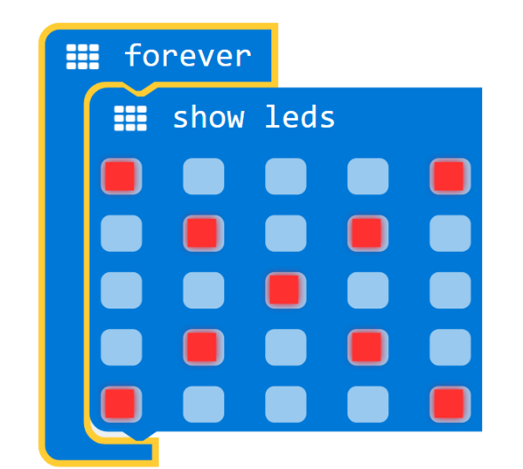

micro:bit code

1. When you are done, move the leds ***show leds*** block into the ***forever*** block.
2. The emulator will show the LEDS light up as programmed.

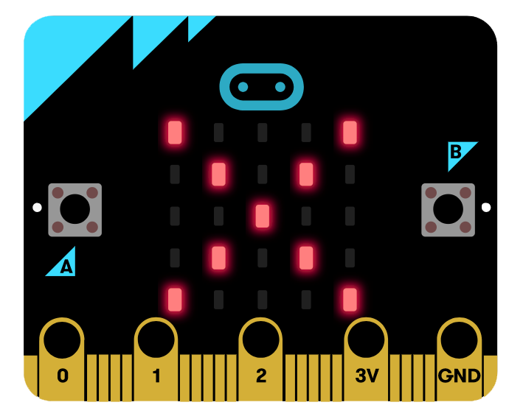

micro:bit display

1. Name your project as ***leds show*** and click on the ***Download*** button or the ***diskette*** icon to save your work. You will find your saved project in the ***Downloads*** folder. The project name is *filename.hex*.

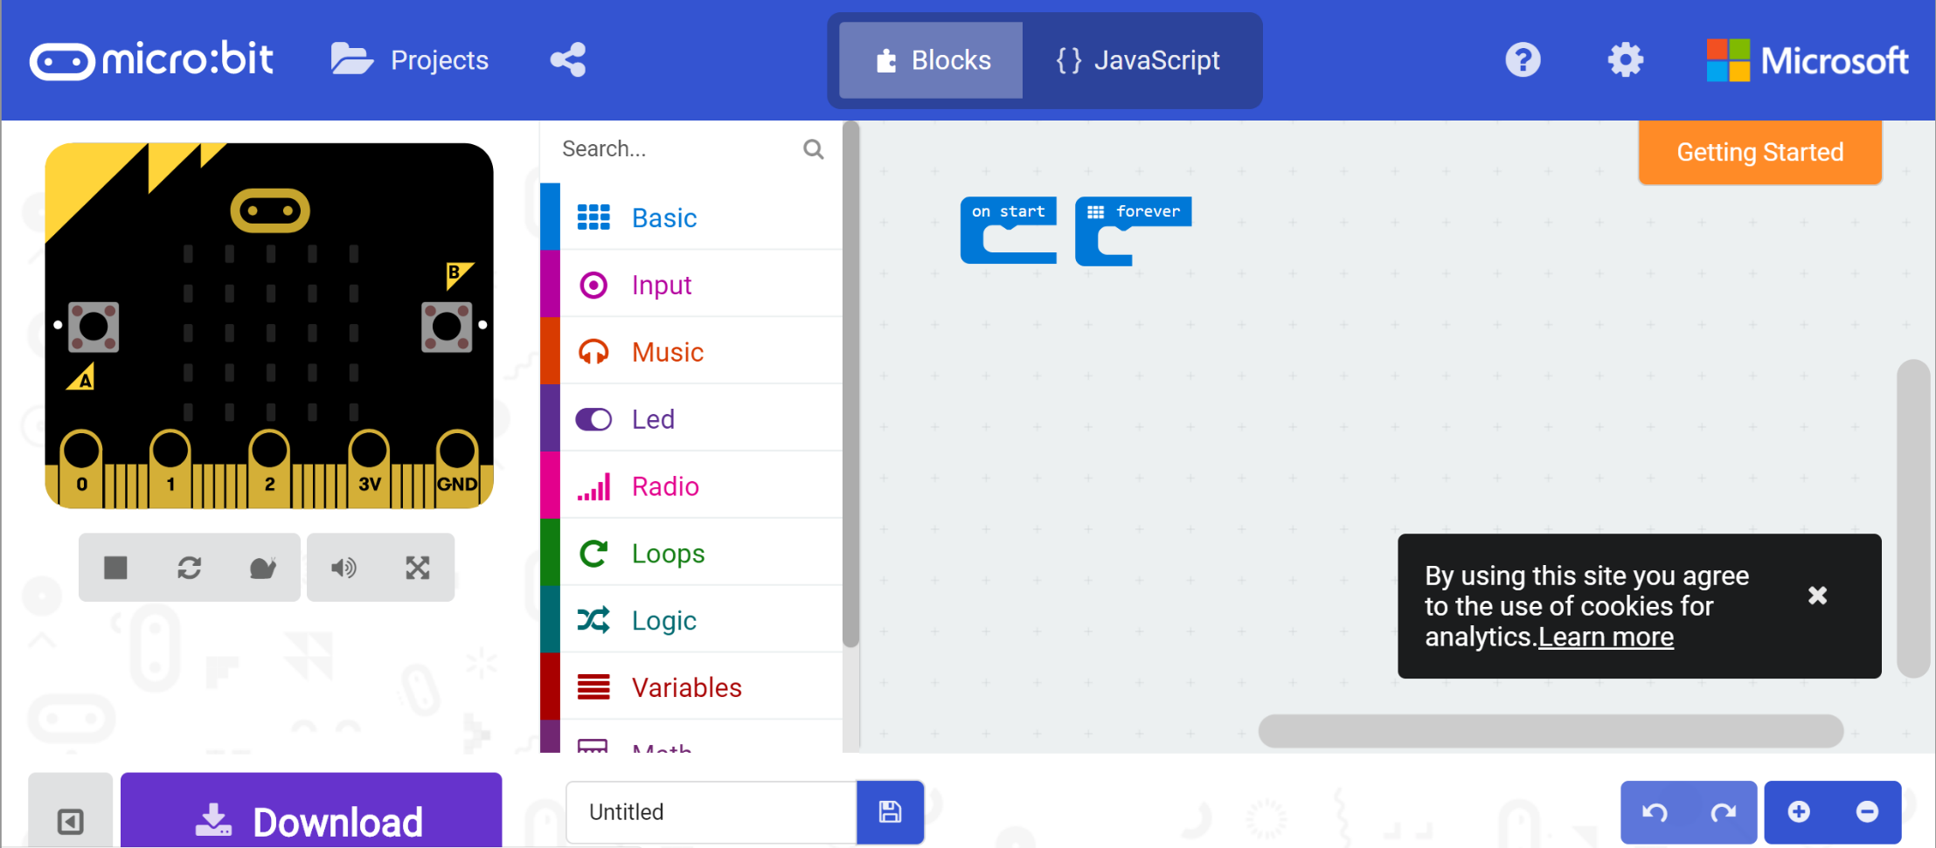

**ACTIVITY 2**

You will be shown the LED animation and your task is to create a program to show the LED animation.

1. Save your project as ***leds animation***.
2. To run your project on the micro:bit programmable computer (microbit) you will need to download the project to the microbit.
3. Connect the micro USB end of the cable to the microbit.

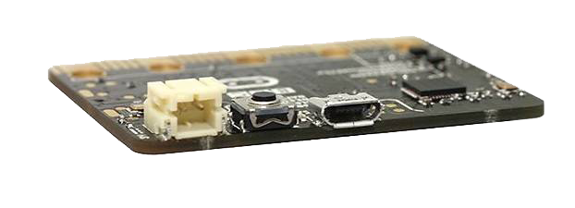

Micro USB port on the microbit

1. Connect the other end of the USB cable to the computer.
2. 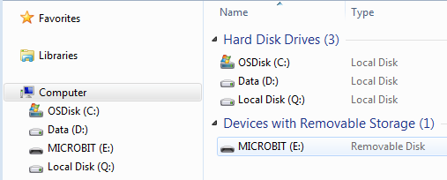The microbit will then appear as a storage device in the computer as ***MICROBIT***.
3. Drag your project (*filename.hex*) into the ***MICROBIT*** drive.
4. When the download is complete, the project will automatically run on the microbit.

**ACTIVITY 3**

Program the microbit to display a string.

1. You will use the ***show string*** and ***forever*** blocks from the ***Basic*** menu to create to display the string (also known as text), ***My name is Student’s Name***.
2. Save your project as ***display name.***
3. Download your project on to the microbit.

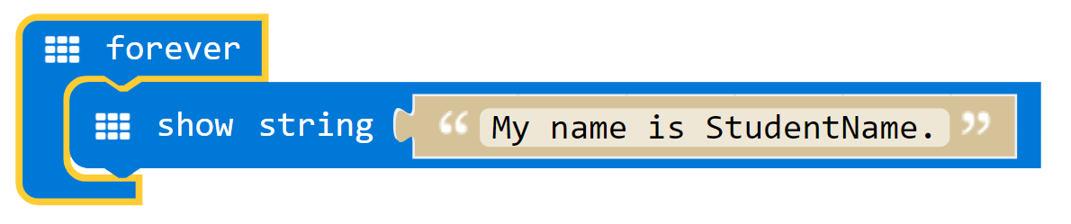

**ACTIVITY 4**

Program the microbit to display a random alphanumeric character when when it receives an input.

1. To display a random number from 0 to 9 use the ***show number*** from ***Basic*** menu, ***pick random 0 to 4*** from the ***Math*** menu and ***on button A pressed*** from ***Input*** menu.

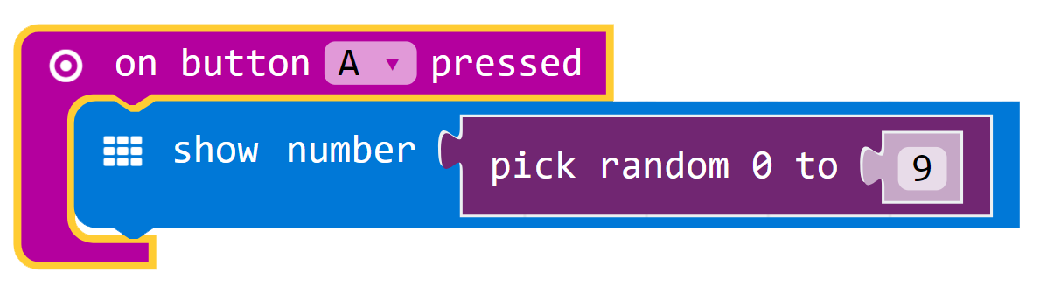

1. To display a random alphabet from A to Z, use the ***show string*** from the ***Basic*** menu, ***text from char code 0*** and ***pick random 0 to 4*** from the ***Math/More*** menu and ***on button B pressed*** from ***Input*** menu.

(*Hint:* Use ASCII where the alphabet A is represented by the number 65 and the alphabet Z is represented by the number 90)

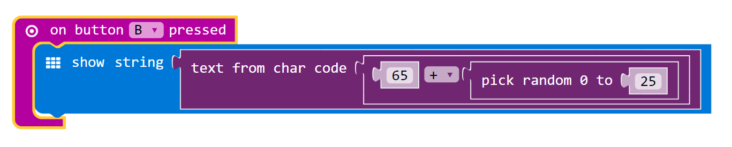

1. Save your file as ***random alphanumeric***.
2. Download the project to the microbit.

*Challenge*: Program the microbit to display the numbers found on a dice when the microbit is shaken.

**ACTIVITY 5**

Program the microbit to display a number which will increase by 1 when the microbit is shaken.

1. Use ***on start***, ***forever***, ***clear screen***, ***show number*** and ***show string*** blocks from ***Basic*** menu.
2. Use ***on button A + B pressed*** and ***on shake*** from ***Input*** menu.
3. Use ***set steps to 0*** and ***change steps by 1*** from the Variable menu.
4. The code is shown here.

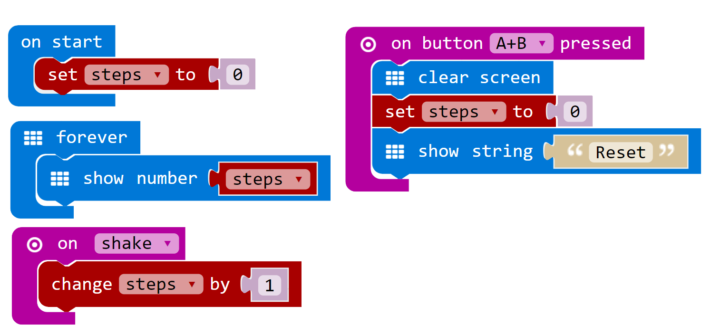

1. Save your project as ***pedometer***.
2. Download the project to the microbit.

**ACTIVITY 6**

Program the microbit to display scissors, paper or stone.

1. The code is as shown below.

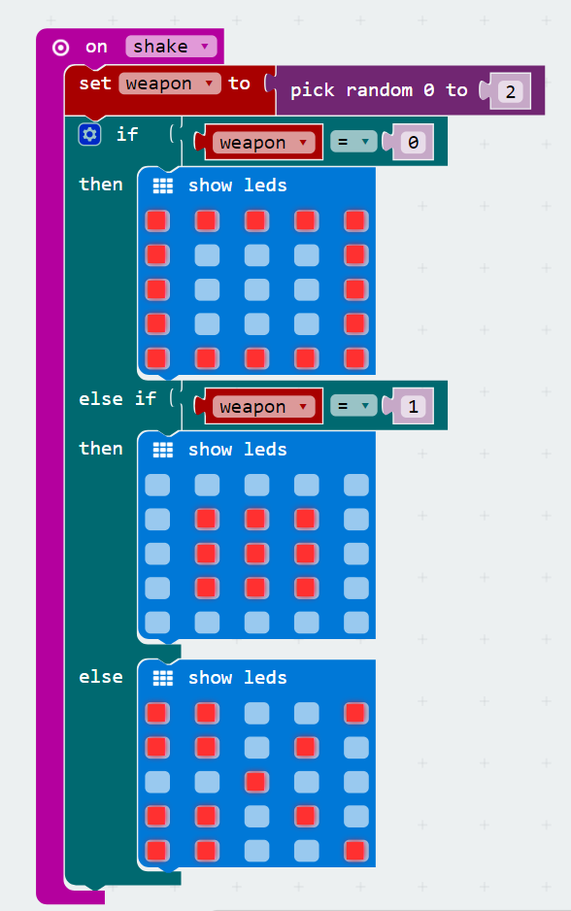

1. Save your project ***as scissors paper stone***.
2. Download the project to the microbit.